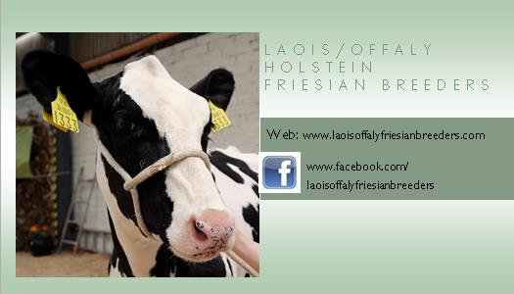
Friday 23rd June 2017
Dear Member,
Our 2nd field evening of the year will take place Thursday 29th June at 7.30 p.m. on the farm of John Moore, home to the “Lemrac” herd, Clyduff, Rhode, Co. Offaly. The sponsors for the night will be Lely Mullingar, World Wide Sires and Progressive Genetics. Paul Flanagan of the North-Eastern Club has kindly agreed to be the Master Judge for the night. Directions to the farm are as follows:
- From Birr, Portlaoise and Tullamore – take the N52 (Tullamore Bypass) and head North towards Kilbeggan until you reach the Ardan roundabout, there will be a steel structure/ derelict building on your left as you approach the roundabout. Take the third exit, “Tinnycross”, and the farm will be signposted from there. Please contact me if you need further details.
I would encourage all members to attend as it promises to be a very enjoyable evening and an oppurtunity to get a closer look at this excellent herd of cows. The “Lemrac” herd was the winner of the Intermediate section in the 2016 LOFBC herds competition and is home to many members of internationally renowned cow families. Currenlty, 78% of the herd is classified either VG or EX.

I also want to take this oppurtunity to remind members of our upcoming calf show and to please note that the date for this years calf show has been postponed to Wednesday 12th July at 7:30 p.m in Tullamore Mart. All members are welcome to take part. For anyone that has never taken part in this show before, there will be a non-clipped January 2017 and March 2017 born calf class so you just need to have the calf halter trained and turn up on the day! Reminder to anyone bringing calves to have “Movement forms” printed off the DAFM website and present on the evening of the show for inspection by the local DVO. Please note the age groups for this years calf classes:

March Calf handled by 10 years and under | Born on or after March 1st 2017
Junior Calf handled by 12 years and under | Born between January 1st and February 28th 2017
Intermediate Calf by 16 years and under | Born between November 1st and December 31st 2016
Senior Calf | Born between August 1st and October 31st 2016
Spring Yearling | Born between March 1st and July 31st 2016
Mature Calf | Born between January 1st and February 29th 2016

As always, more information can be found on our website www.laoisoffalyfriesianbreeders.com or our facebook page. Information on national IHFA events can be found on the IHFA website.

Yours Sincerely,
Enda Neville

Contact Details
Officer | Position | Address | Mobile No. | Email
Enda Neville | Club Secretary | Ballydaly, Tullamore, Co. Offaly | 086 061 0338 | eneville@live.com
Helen Kelly | Chairperson | Bloomfield House, Portlaoise, Co. Laois | 087 284 1387 | helenkelly09@gmail.com
Denis Donohoe | Treasurer | Oldcourt, Ballylinan, Athy, Co. Laois | 086 380 0000 | donohoedenis@eircom.net
John Gill | PRO | Kilgolan House, Kilcormac, Birr, Co. Offaly | 087 870 4623 | johngill@iol.ie

